JAVA LAB PROGRAM

Submitted by,

Tamilvanan B.

2018503566.

MO Batch.

10-27-2020.

Write a Java program that displays a greeting message and then prompt for and read the name of the input file. The program then connects an input stream to that file so that we can read from it, and print a message if the stream does not open correctly. It should then prompt for and read the name of the output file. The program should then try to connect an output stream to that file so that we can write to it, and print a message if the stream does not open correctly. For each character in the input file, the program should read the character, encode it using the Caesar cipher, and output the encoded character to the output file. The program should end by disconnecting the streams from the files, and then print a "success" message.

Program

import java.util.Scanner;

import java.io.\*;

import java.io.File;

import java.io.FileReader;

import java.io.FileWriter;

import java.io.FileOutputStream;

import java.io.PrintStream;

import java.io.IOException;

public class CaesarCipher {

public static StringBuffer encrypt(String text, int s) {

StringBuffer result= new StringBuffer();

for (int i=0; i<text.length(); i++) {

if (Character.isUpperCase(text.charAt(i))) {

char ch = (char)(((int)text.charAt(i) + s - 65) % 26 + 65);

result.append(ch);

}

else{

char ch = (char)(((int)text.charAt(i) + s - 97) % 26 + 97);

result.append(ch);

}

}

return result;

}

public static void main(String... args) throws IOException {

Scanner sc = new Scanner(System.in);

System.out.print("Welcome!\n");

System.out.print("Enter the file name: ");

String text = sc.next();

File file = new File(text);

FileReader reader = new FileReader(file);

char chars[] = new char[(int) file.length()];

BufferedReader br = new BufferedReader(reader);

int j = 0;

int i;

while((i =br.read())!= -1){

chars[j] = (char)i;

j++;

}

String str = new String(chars);

System.out.print("Enter the number of shift: ");

int s = sc.nextInt();

StringBuffer res = encrypt(str, s);

String ans = res.toString();

char[] charArr = ans.toCharArray();

System.out.print("Enter the file name: ");

String opstr = sc.next();

File out = new File(opstr);

FileWriter writer = new FileWriter(out);

BufferedWriter buffer = new BufferedWriter(writer);

buffer.write(charArr);

buffer.close();

FileOutputStream f1 = new FileOutputStream("fi.txt");

PrintStream outp = new PrintStream(f1);

outp.print("Success");

outp.println();

outp.flush();

outp.close();

}

}

Output

Before running the program

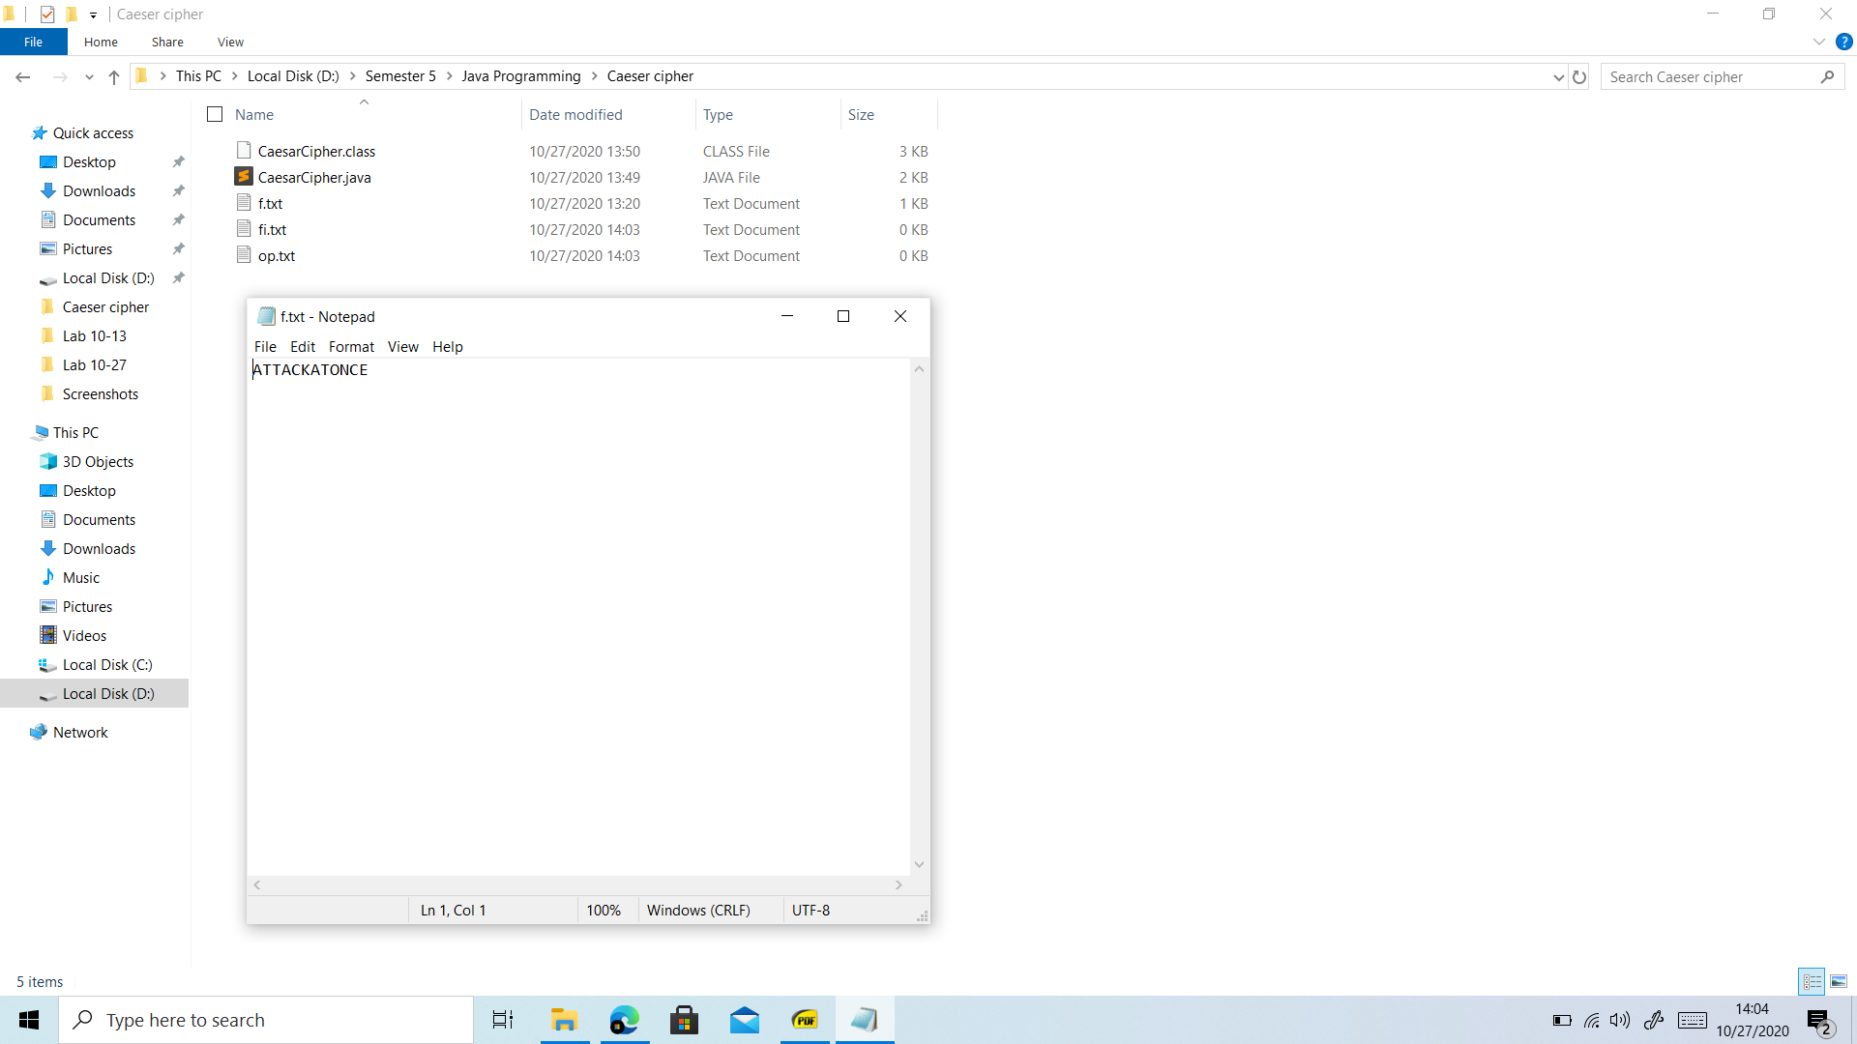

Running the program

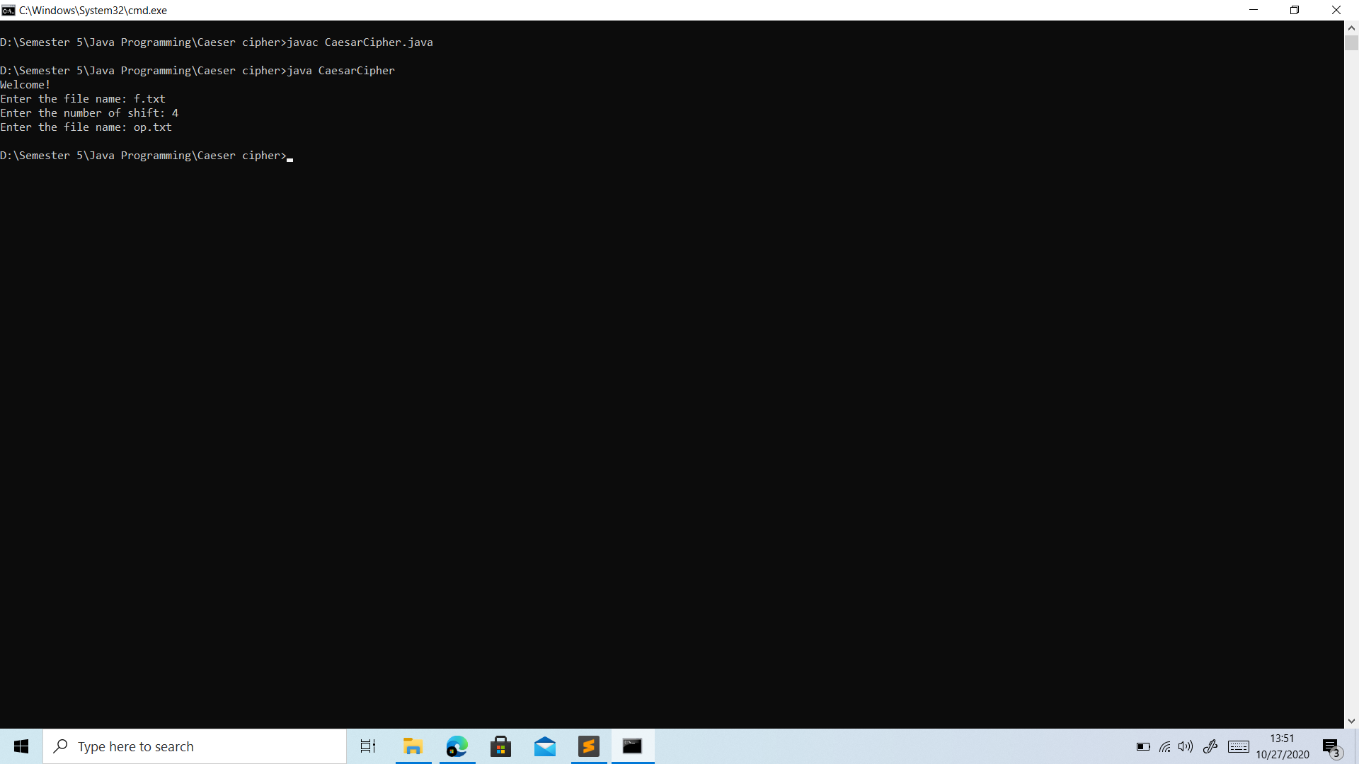

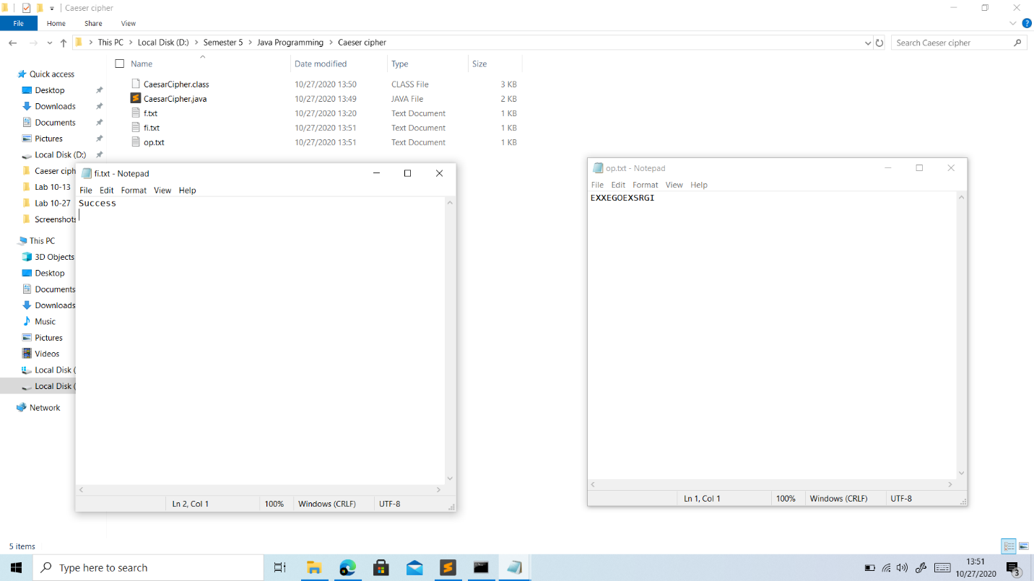After running the program